##### Crossbody Bag

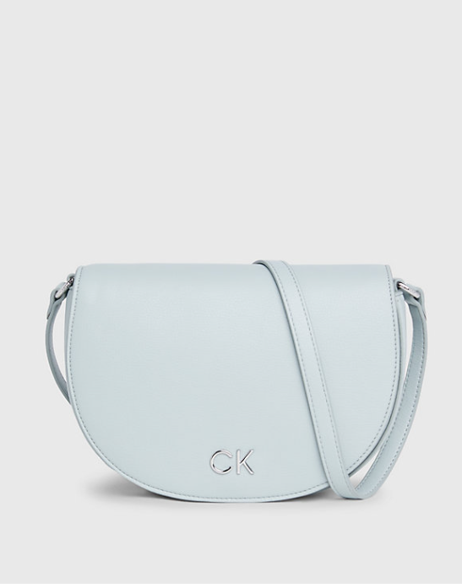

Crossbody Bag in light blue

A light blue crossbody bag sounds like a charming accessory! Are you looking for recommendations or just sharing your style choice

1. **Choose the Right Bag**: First, select a crossbody bag that fits your personal style and the occasion. Consider factors like size, color, material, and design. For a casual look, opt for a smaller, lightweight bag in a fun color or pattern. For a more formal occasion, choose a sleek, structured bag in a neutral tone.
2. **Coordinate with Your Outfit**: Your crossbody bag should complement your outfit rather than clash with it. Consider the colors, patterns, and textures of your clothing when selecting a bag. For example, if you're wearing a floral dress, a solid-colored bag in a complementary shade can tie the look together.
3. **Adjust the Strap Length**: Crossbody bags typically have adjustable straps, allowing you to customize the length for comfort and style.